**ASSIGNMENT 3**

**Problem Statement:** Apply appropriate ML algorithm on a dataset collected in a cosmetics shop showing details of customers to predict customer response for special offers.

**S/W Packages and H/W apparatus used:**

Software used:

1. Python 3.x

2. Google Colab

Libraries and packages used: NumPy, Pandas

# Theory:

# the steps for applying an appropriate machine learning algorithm to predict customer response for special offers in a cosmetics shop:

To predict customer response for special offers based on details of customers collected in a cosmetics shop, you can use various machine learning algorithms, depending on the nature of your dataset and the problem at hand.

1. Understanding the Problem:

Objective: The objective is to predict whether a customer will respond positively or negatively to special offers.

Dataset: The dataset contains details of customers such as age, gender, income, purchasing history, etc., along with their response to previous offers.

2. Exploratory Data Analysis (EDA):

Boxplot: Boxplots can be used to visualize the distribution of numerical features in the dataset and to identify any outliers.

Heatmap: Heatmaps can be used to visualize the correlation between different features in the dataset, helping in feature selection and understanding feature importance.

3. Preprocessing:

Handling Missing Values: Deal with missing values by imputation or removal, depending on the extent of missingness.

Encoding Categorical Variables: Convert categorical variables into numerical format using techniques like one-hot encoding or label encoding.

Feature Scaling: Scale numerical features to a similar range to prevent one feature from dominating others during model training.

4. Model Selection:

Classification Algorithms: Since the problem involves predicting a binary outcome (responding positively or negatively), classification algorithms are suitable.

Potential Algorithms: Algorithms such as Logistic Regression, Decision Trees, Random Forest, Support Vector Machines (SVM), Gradient Boosting, or Neural Networks can be considered.

5. Model Evaluation:

Train-Test Split: Split the dataset into training and testing sets to evaluate the model's performance.

Evaluation Metrics: Use appropriate evaluation metrics such as accuracy, precision, recall, F1-score, or area under the ROC curve (AUC-ROC) depending on the class distribution and business requirements.

6. Model Tuning and Optimization:

Hyperparameter Tuning: Optimize the model hyperparameters using techniques like Grid Search or Random Search to improve model performance.

Cross-Validation: Perform cross-validation to ensure the model's generalization ability and reduce overfitting.

7. Model Deployment and Monitoring:

Deployment: Once the model is trained and evaluated satisfactorily, deploy it in the production environment to make predictions on new data.

Monitoring: Continuously monitor the model's performance and retrain/update it periodically to maintain its accuracy and relevance.

**Advantages:**

1.Optimized Resource Allocation: Machine learning algorithms can optimize resource allocation by identifying segments of customers with similar characteristics and response patterns. This allows the cosmetics shop to allocate marketing budgets more efficiently, focusing efforts on high-value customer segments likely to generate the highest return on investment.

2.Real-time Decision Making: With the ability to process data in real-time, machine learning models enable the cosmetics shop to make timely decisions regarding special offer campaigns. By continuously analyzing customer interactions and feedback, the shop can adapt its marketing strategies dynamically to maximize effectiveness.

**Diagram:** 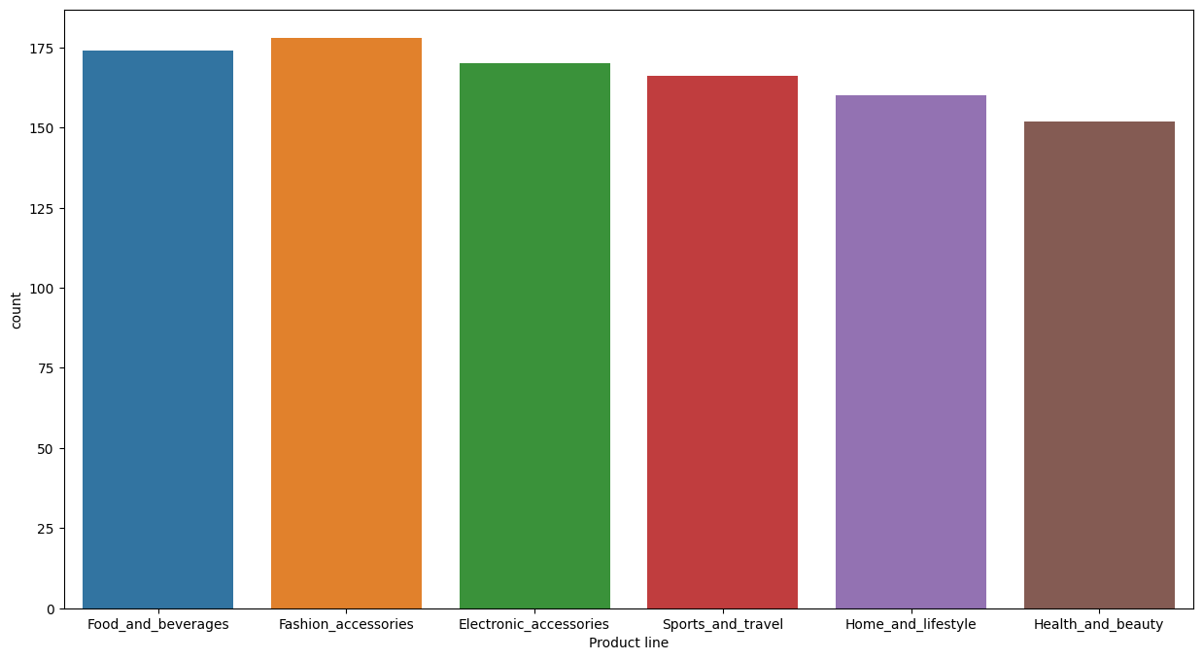 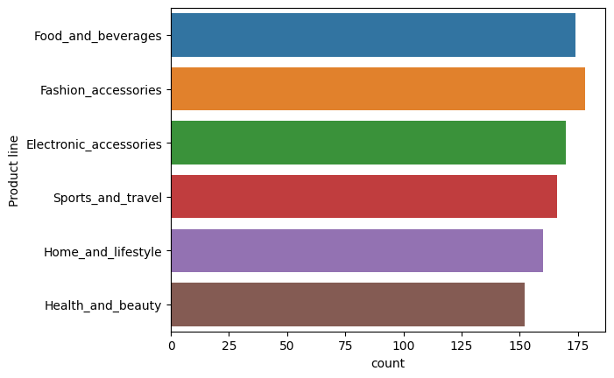

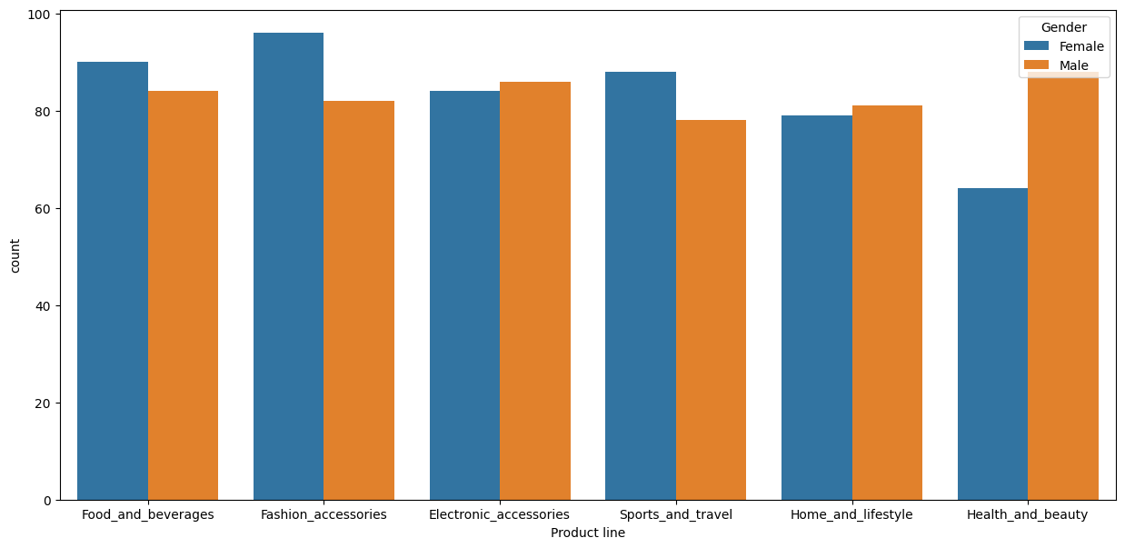

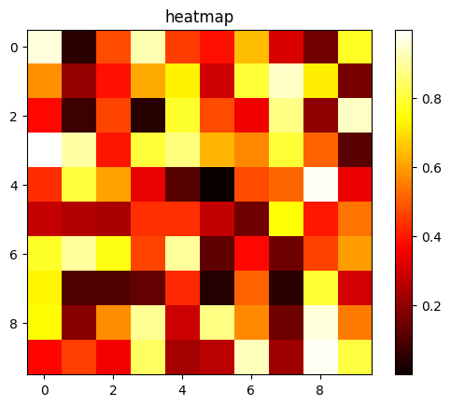

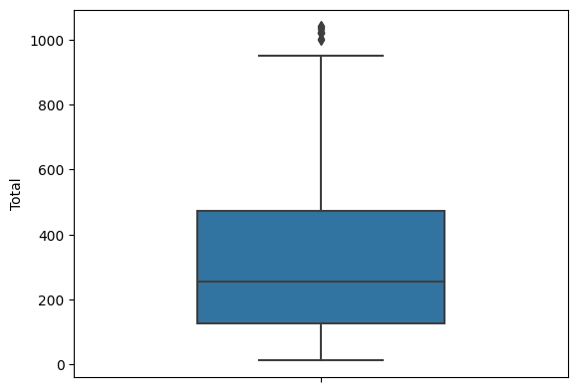

**Conclusion:** In conclusion, leveraging machine learning algorithms to predict customer responses to special offers in a cosmetics shop offers numerous advantages that can significantly impact business outcomes. By analyzing vast amounts of customer data, these algorithms enable personalized marketing strategies, improved customer engagement, and optimized resource allocation. Real-time decision-making capabilities, coupled with insights generated from predictive models, provide the shop with a competitive advantage in the market.